FASHION HEAVEN
1.Project Introduction
Introduction to the " Fashion Heaven " project.
Objectives and goals of the project.
1.1 Project Overview
Fashion heaven aim to describe the creation clothings of different cultural aesthetics and their mix and match into outfits that depict distinctive ways of dressing as signifiers of social status, self-expression, and group belonging.
1.2 Purpose
The purpose of fashion heaven is to increase self-confidences of a person. Many people struggle with this, but the right piece of clothing in the right situation can boost a person’s mood and completely transform them.It will to help create an idea of what we think about their personality. Wearing what makes you comfortable is a statement, and people will respect your individuality.
2. Problem Definition and Design Thinking
2.1 Empathy Map
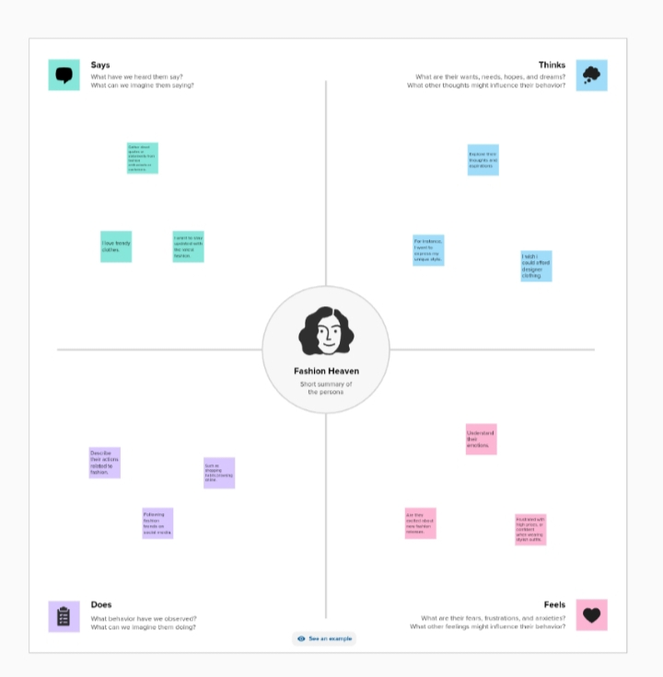

2.2 Ideation and Brainstorm
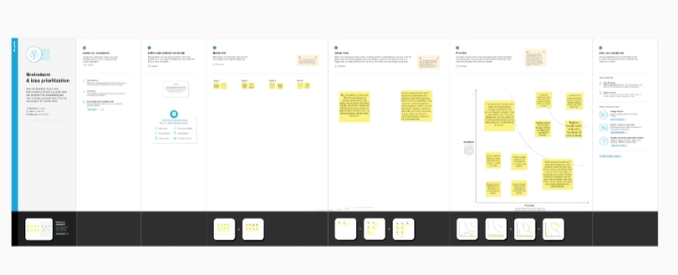
3. Result
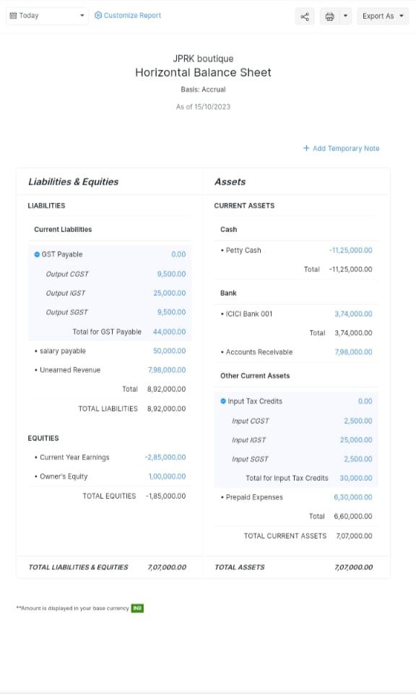

4. Advantages and Disadvantages
Advantages
- It keeps a society lively through different new styles and subsequent changes.
- It could develop your personality the people, in your company, get impressed by you and follow you as a model.
- It gives confident and do bold things in the society, you experience a sense
Disadvantages
- Chemicals are used for clothing life cycle, from fabric production, to treatment, through to their use as they are washed. The more clothing items that are produced, the more chemicals are used.
- Some clothes may not be inclusive of all body types, leading to body image issues and self-esteem issues.
- It can be more expensive.

5.Applications
It is an art form an culture, identity, and creativity, shaping our perception of ourselves and the world around us. It could express individuality, create trends, and communicate personal style through clothings.The clothes we wear tell stories of our culture and our heritage.
6. Conclusion
This program had been successfully executed.
7. Future Scope
Zoho develpement is going to focus on cloud service.
8. Appendix
A. Source code

